Instructions for Producing Camera-Ready
Manuscript using mS-WORD FOR PUBLICATION IN
CONFERENCE PROCEEDINGS
FIRST AUTHOR†
University Department, University Name, Address
City, State ZIP/Zone, Country
Email: wspc@wspc.com
SECOND AUTHOR
Group, Laboratory, Address
City, State ZIP/Zone, Country
Email: wspc@wspc.com.sg
This is where the abstract should be placed. It should consist of one paragraph giving a concise summary of the material in the article below. Replace the title, authors, and addresses with your own title, authors, and addresses. You may have as many authors and addresses as you like. It is preferable not to use footnotes in the abstract or the title; the acknowledgments of funding bodies etc. are to be placed in a separate section at the end of the text.

Guidelines

Producing Hard Copy Using MS-Word
You can delete our sample text and replace it with the text of your own contribution to the proceedings. However we recommend that you keep an initial version of this file for reference.
Page numbers are included at the top of the page for your guidance. The final pagination of the volume will be done by the Publisher.a
If you want to use some other form of word-processor to construct your output, and you are using the final hard copy version of these files as guidelines; then please follow the style given here for headings, table and figure captions, and the footnote and citation marks. The book trim size will be 9 by 6 inches; however you should submit your ms copy on standard A4 paper. The text area including page numbers should be 7.35 by 4.7 inches, except for opening page. The text should be set in 10 pt roman with a leading (interline spacing) of 13 pt. Type the title of the paper in 11 pt boldface, Arial and in upper case. The 1st section heading is in 11 pt boldface, Arial, uppercase. The 2nd section heading is in 11 pt boldface, Arial, upper and lowercase. If there is a 3rd section heading then it should be 11 pt italic, Arial, upper and lowercase. Authors’ names are set in 9 pt and in upper case. Addresses are in 9 pt italics. The abstract, figure and table captions should be in 8 pt. Footnotes are set in 8 pt.
It is also important to reproduce the spacing of the text and headings as shown here. All headings should be separated from the text preceding it by a vertical space of about 12 pt and by 6 pt from the subsequent text.
Paragraphs should have its first line indented by about 0.25 inch except where the paragraph is preceded by a heading and the abstract should be indented on both sides by 0.25 inch from the main body of the text.

Headings
Please preserve the style of the headings, text font and line spacing in order to provide a uniform style for the proceedings volume.

List
Lists may be laid out with each item marked by a number:

- Item one
- Item two
- Item three
- Item four

Marked by a lowercase roman letter:

- Item one
- Item two
- Item three
- Item four
Marked by a bullet
- Item one
- Item two
- Item three
- Item four

Tables
The tables are designed to have a uniform style throughout the paper? It does not matter how you choose to place the inner lines of the table, but we would prefer the border lines to be of the style shown in Table 1. For the inner lines of the table, it looks better if they are kept to a minimum. The caption heading for a table should be placed at the top of the table.

Table 1. First five normalized natural frequencies of a clamped beam with internal hinge at 4 different locations.

 | A = 0.56 | B = 0.69 | C = 0.75 | D = 0.100
AB₁ | 14.0640 | 18.5620 | 22.0817 | 18.90732
AC₂ | 61.6728 | 44.7844 | 44.5884 | 60.17496
AD₃ | 88.1380 | 118.1564 | 101.2240 | 120.33553
DB₄ | 199.8594 | 173.1269 | 194.4907 | 188.75258
DA₅ | 246.7889 | 255.9483 | 284.6633 | 262.24264

Figures/Illustrations
Authors are advised to prepare their figures in black and white. Please prepare the figures in high resolution (300 dpi) for half-tone illustrations or images. Half-tone pictures must be sharp enough for reproduction, otherwise they will be rejected.
Colour images are allowed only when they are stated in the publishing agreement. The colour images must be prepared in CMYK (Cyan, Magenta, Yellow and Black). RGB colour images are not acceptable for colour separation.
It is best to embed the figures in the text where they are first cited, e.g. see Fig. 1. Please ensure that all labels in the figures are legible irregardless of whether they are drawn electronically or manually.
If you prefer to submit glossy prints of figures, then it is very important to leave sufficient blank spaces in your manuscript to accommodate your figures. Send the hard copy of the figures on separate pages with clear instructions on where to match them to the respective blank spaces in the final hard copy text. Please ensure that each figure is correctly scaled (ensure legibility) to fit the space available. The caption heading for a figure should be placed below the figure. Very large figures and tables should be placed on a page by themselves.

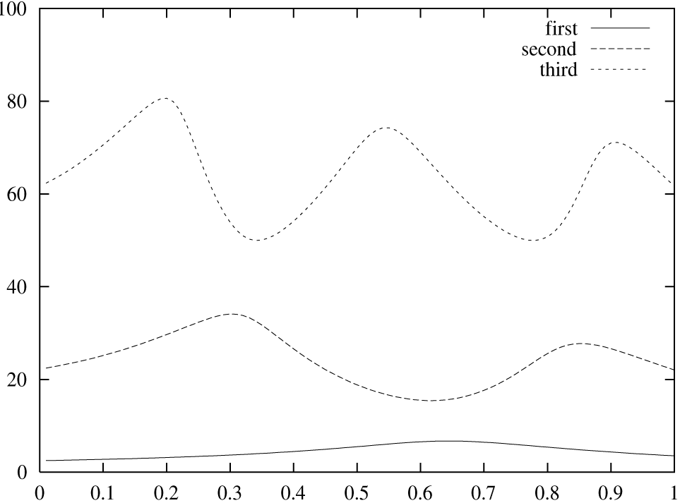

Fig. 1. Short captions should be centered. Long captions (captions with more than 1 line) should be justified.

Final Manuscript
The final hard copy that you submit must be absolutely clean and unfolded. It will be printed directly without any further editing. The feature “draw Text Border” at WSPC toolbar will produce a bounding box in the type area. Please use this command while you do paging but do not forget to delete it by selecting “remove Text Border” while you are doing the Final corrections. Use a printer that has a good resolution printout (600 dpi or higher). There should not be any corrections on the printed pages, nor should adhesive tape cover any lettering. Photocopies are not acceptable.
Your manuscript will not be reduced or enlarged when filmed so please ensure that indices and other small pieces of text are legible.

Acknowledgments, Footnotes and the Bibliography
If you wish to acknowledge funding bodies etc., the acknowledgments may be placed in a separate section at the end of the text, before the Appendices.

Footnotes
Footnotes are denoted by a character superscript in the text,b and references are denoted by a number superscript.
Acknowledgments
This is where one acknowledges funding bodies etc. Note that section numbers are not required for Acknowledgments and References.
References
References must be submitted in the correct style for this volume. The references will be listed in alphabetical order at the end of the text, beginning on a separate sheet. Within the text, the references will appear as superscript numerals according to the sequence they appear in the text.^{4,5-9} Authors must pay particular attention to the accuracy of references which should be checked before final submission of the finished manuscript. The following are some examples of references.

Journal Article:
Rogers WD, Watson HK. Radical styloid impingement after triscaphe arthrodesis. J Hand Surg 1989; 14A: 297–301.

Books:
Taleisnik J. The Wrist. New York: Churchill Livingstone, 1985: 15–20.

Chapters in Edited Book:
Beckenbough RD, Linscheid RL. Arthroplasty in the hand and wrist. In: Green DP, ed. Operative Hand Surgery, 2nd ed. New York: Churchill Livingstone, 1988: 167–214.

With the listing at the end as follows:

- Andrew JG, Sykes PJ. Duplicate thumbs: A survey of results in twenty patients. J Hand Surg 1988; 13B: 50–53.
- Bilhaut. Guerison d’un pouce bifide par un nouveau procede operatoire. Congres Francais de Chirurgie 1889; 4: 576–580.
- Dobyns JS, Lipscomb PR, Cooney WP. Management of thumb duplication. Clin Orthop 1985; 195: 26–44.
- Bilhaut. Guerison d’un pouce bifide par un nouveau procede operatoire. Congres Francais de Chirurgie 1889; 4: 576–580.
- Andrew JG, Sykes PJ. Duplicate thumbs: A survey of results in twenty patients. J Hand Surg 1988; 13B: 50–53.
- Bilhaut. Guerison d’un pouce bifide par un nouveau procede operatoire. Congres Francais de Chirurgie 1889; 4: 576–580.
- Dobyns JS, Lipscomb PR, Cooney WP. Management of thumb duplication. Clin Orthop 1985; 195: 26–44.
- Andrew JG, Sykes PJ. Duplicate thumbs: A survey of results in twenty patients. J Hand Surg 1988; 13B: 50–53.
- Bilhaut. Guerison d’un pouce bifide par un nouveau procede operatoire. Congres Francais de Chirurgie 1889; 4: 576–580.
- Dobyns JS, Lipscomb PR, Cooney WP. Management of thumb duplication. Clin Orthop 1985; 195: 26–44.

* This work is supported by etc, etc.
† Work partially supported by grant 2-4570.5 of the Swiss National Science Foundation.
a You can obtain these files from our WWW pages at: http://www.wspc.com.sg/style/proceedings_style.shtml
b Just like this one.

